Linux Command Practice – Screenshots and Command Reference
Image 1 – Creating Directories and Files
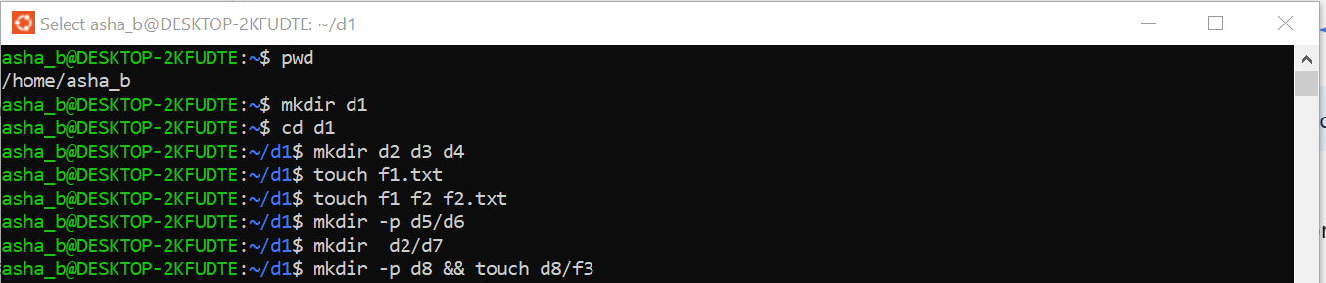
No. | Command | Purpose
1 | Pwd | Displays the current working directory.
2 | mkdir d1 | Creates a directory named d1.
3 | cd d1 | Moves into the d1 directory.
4 | mkdir d2 d3 d4 | Creates d2, d3 and d4 directories.
5 | touch f1.txt | Creates an empty file named f1.txt.
6 | touch f1 f2 f2.txt | Creates the files f1, f2 and f2.txt.
7 | mkdir -p d5/d6 | Creates d5 and the d6 directory inside it.
8 | mkdir d2/d7 | Creates d7 inside d2.
9 | mkdir -p d8 && touch d8/f3 | Creates d8 and then creates f3 inside d8.

Image 2 – Navigation and Checking the Directory Structure
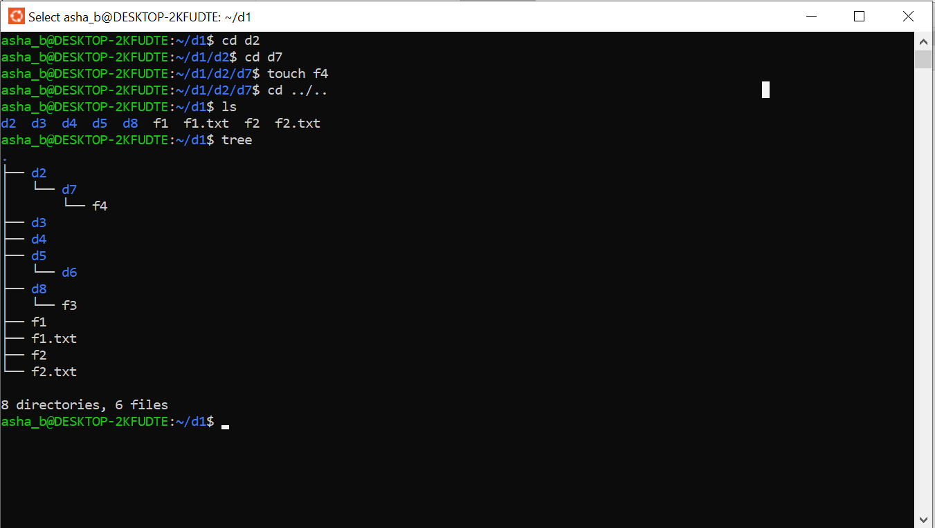
No. | Command | Purpose
1 | cd d2 | Moves into the d2 directory.
2 | cd d7 | Moves into the d7 directory.
3 | touch f4 | Creates an empty file named f4.
4 | cd ../.. | Moves up two directory levels.
5 | ls | Lists the files and directories in the current directory.
6 | tree | Displays the directory and file structure in tree form.

Image 3 – Removing Files and Directories
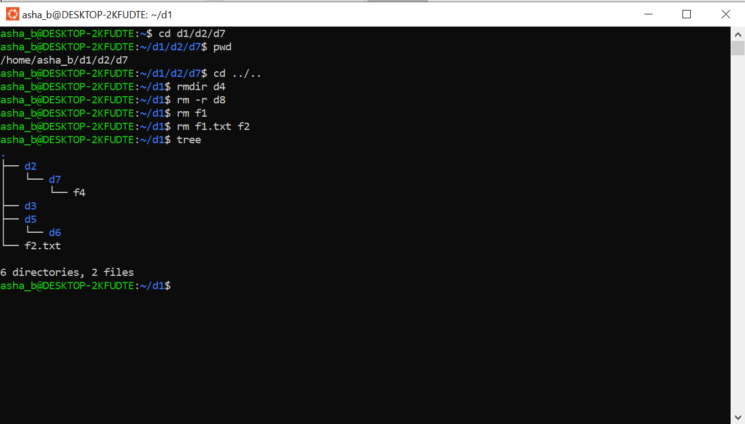
No. | Command | Purpose
1 | cd d1/d2/d7 | Moves directly to d7 using the given path.
2 | pwd | Displays the current working directory.
3 | cd ../.. | Moves up two directory levels.
4 | rmdir d4 | Removes the empty d4 directory.
5 | rm -r d8 | Removes d8 and its contents recursively.
6 | rm f1 | Removes the file f1.
7 | rm f1.txt f2 | Removes f1.txt and f2.
8 | tree | Displays the final directory and file structure.

